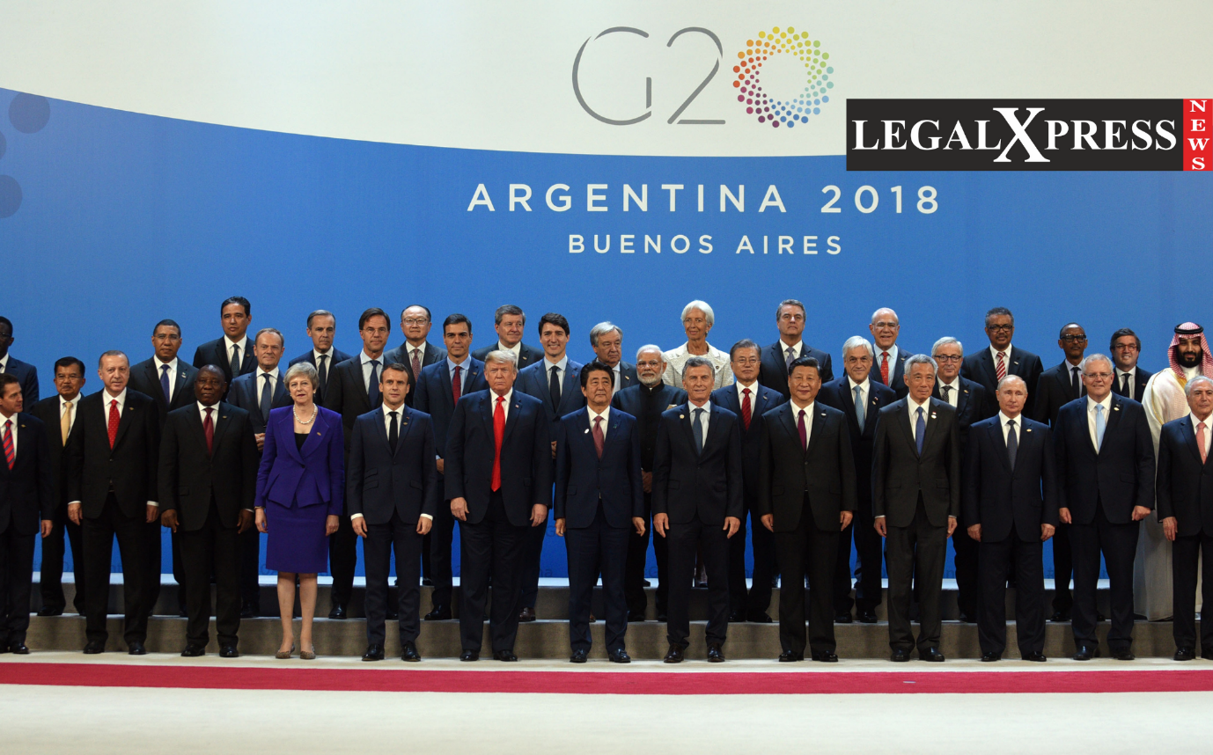
CHINA OPPOSES INDIA'S VIEW OF HOLDING G20 MEETING IN JAMMU AND KASHMIR.

By:
K. PRAMOD KUMAR REDDY

HIGHLIGHTS:
- This time it is India’s turn to host the G20 meeting in 2023 and India is planning to hold 2023 G20 meeting in Jammu and Kashmir.
- China along with Pakistan are opposing the idea of holding the G20 meeting in Jammu and Kashmir.
- Chinese Foreign Minister Zhao Lijian said that, “I have taken note of the Situation”. And he is opposing the idea of India on holding the 2023 G20 meeting in Jammu and Kashmir.

This time in the year 2023 India is planning to host the G20 meeting in Jammu and Kashmir. The reason for doing so is to get more international media attention and also to get foreign investments into the state of Jammu and Kashmir. This done for another reason as well, which is to increase the tourists attention towards Jammu and Kashmir. But China and Pakistan are opposing the Idea of planning G20 meeting in Jammu and Kashmir.
The G20 meeting is one of the multilateral meetings where 20 countries that are part of the G20 come together to discuss and have meetings over different situations and developments. G20 stands for the group of twenty. And the G20 is currently comprised of 19 countries and the EU. And India is a member of this G20. This time India is planning to host the G20 meetings in Jammu and Kashmir and has appointed Shri Piyush Goyal as the Sherpa for the 2023 meetings. The reason for planning so by India is to get more foreign investments into Jammu and Kashmir and get more attention from the tourists. This also brings a lot of media attention worldwide to the Jammu and Kashmir issue India had with China and Pakistan. However, China and also Pakistan are opposing the plan on hosting the G20 meeting in Jammu and Kashmir. The Foreign Affairs Minister of China Zhao Lijian has responded to the decision. He stated, “I have taken note of the Situation”. Then he said that the matter of conflict over the POK (Pakistan occupied Kashmir) and COK (China occupied Kashmir) has long been an issue on both sides and these issues have to be resolved with the proper EU laws application and peace meeting between the countries, which are India, Pakistan, and China. China is suggesting having dialogs and meetings address the issues in Kashmir, but not through the intervention of other countries. The Chinese minister also said, even after all these requests if India goes ahead with holding the G20 meeting in Kashmir will cause severe disparities between India and China. On the other side, Pakistan is trying to reach out to some members of the G20 such as Turkey and Saudi Arabia to vote against holding the meeting in Kashmir. But those countries have not yet responded to the request of Pakistan. Since we all know, that Kashmir has been the center of the issue between India and China, Pakistan. And a lot of these Anti governmental works are done within the territory of India but these are idealized and planned outside of the Indian Territory. Also, China is building a China-Pakistan Economic corridor in the POK region even though India has opposed this and rising concerns over the matter no international media gave attention to this issue. To end this, India has tried to bring international media attention to Kashmir but failed many times. But this time the situation has changed and hosting the G20 meeting in Kashmir can bring international media attention to Kashmir during the G20 meeting India can also raise this issue where this issue can be addressed, as the two major powers, those are United States of America and Russia are in the Group, this issue can see some new light shedding on it. Yet even after all the opposition from China and Pakistan, India is still going with the plan of hosting the 2023 G20 meeting in Kashmir in the Jammu and Kashmir state of India.

