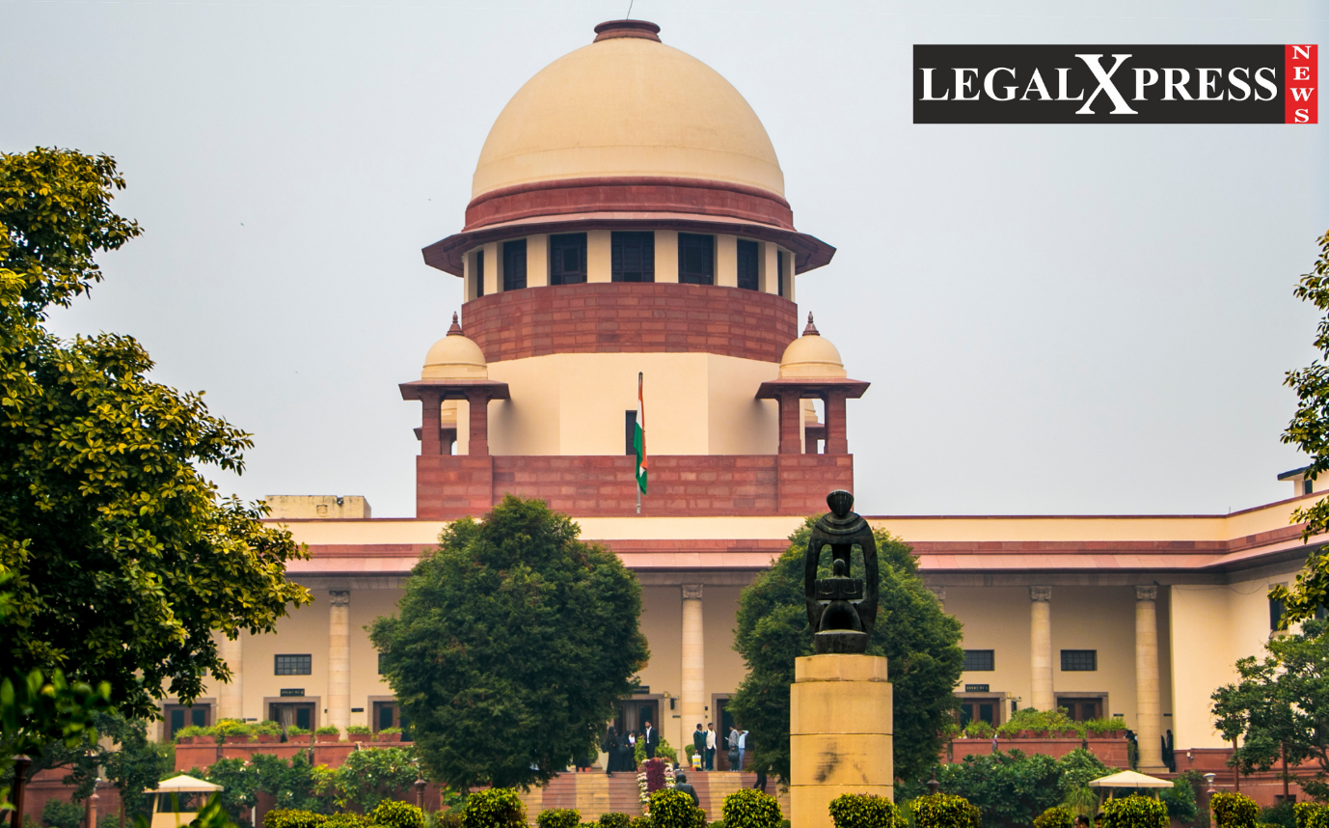
POLITICAL CRISIS: SUPREME COURT TO HEAR PLEAS ON JULY 11.

By:
K. PRAMOD KUMAR REDDY.

HIGHLIGHTS:
- Major Political Turmoil in the Maharashtra Government, Uddhav Thackeray has filed disqualification Plea to the Supreme Court over the 12 Rebel MLA’s including Eknath Shinde.
- Floor Test was passed to show the majority on 29th June, 2022. But the Floor test got called off.
- Supreme Court to Hear Pleas over the disqualifications of the Rebel Shiv Sena MLA’s, and the Anti-Defection Law is in Picture for the 11th July hearing in the Supreme Court.

On 27th of June 2022 the Supreme Court of India has listed a plea hearing over the disqualification pleas filed by Uddhav Thackeray over the 12 Rebel MLA’s of the Shiv Sena including Eknath Shinde under the Anti-Defection Law.

Anti-Defection: Disqualification motion in front of the Supreme Court:
In the current events, there is a huge crisis in Maharashtra politics; the MVA party got served with a No-confidence bill in their State Assembly. The 19th CM Uddhav Thackeray resigned from the post, and the New Rebel Shiv Sena head Eknath Shinde on 30th June, took an oath to be the 20th CM of Maharashtra. Uddhav Thackeray has filed pleas in the Supreme Court over 12 of the Rebel New Shiv Sena MLA’s disqualification, including Eknath Shinde. The Anti-Defection Law was used as the ground to file the pleas. As per the Anti-defection Laws 52nd Amendment, when 2/3rd of party members came out of the ruling party and formed a coalition with another party, those defectors will not be disqualified. The Apex court bench led by Justice Surya Kant has listed a hearing date for those pleas on the 11th of July, 2022. But so concerned, the current new Shiv Sena under the leadership of Eknath Shinde may not be disqualified when we assess the situation with the provisions given under Schedule 10 of the Constitution of India.

Background:
On the 22nd of June 2022, 37 MLAs of Shiv Sena have chosen to leave the party under the leadership of Eknath Shinde. The members who left the party flew to Surat in Gujrat for refuge. Later all the Rebel MLAs formed a new party under the same name of Shiv Sena and passed a No-confidence bill in the Maharashtra Assembly to remove the then CM Uddhav Thackeray. The bill was passed, and the Ex-CM was made to resign. Then on 29th June 2022, New Shiv Sena, in coalition with the BJP, formed a new Government in the State of Maharashtra. The governor passed a Floor test per Article-174 of the Constitution of India to prove the majority by Uddhav Thackeray but later got called off. Uddhav Thackeray has filed pleas to disqualify the 12 MLA’s including Eknath Shinde, under the Anti-Defection laws, claiming they have violated the rules. In view of these claims, the Supreme Court bench, led by Surya Kant, has been looking into the case. The Apex Court has also said that the hearing of the pleas will be postponed to the 11th of July 2022. Until the next hearing date, the Court has ordered the Maharashtra Assembly to hold the disqualification of the Rebel MLAs. The Apex Court is looking to deal with the Disqualification with Anti-Defection Laws view. Experts say that even under the Anti-Defection laws, these MLAs cannot be disqualified after they have fulfilled the provision by coalition with another party, i.e. BJP. There is another issue with the usage of the name Shiv Sena, and the same party symbol by the Rebel members may be contested in the future. However, the decision is yet in the hands of the Supreme Court. And the Next hearing date of the pleas is listed on the 11th of July 2022.

